JOMO KENYATTA UNIVERSITY OF AGRICULTURE & TECHNOLOGY
BIT 2325: Computer Graphics & Animation
Milestone 2 — Space, Transformation & Camera
Topic: Procedural Content Generation Systems

Field | Details
Group Members | Esther Achieng Otieno — SCT221-C004-0317/2024  Wendy Wachira — SCT221-C004-0194/2023  Wangui Ninsima Irimu — SCT221-C004-0217/2024  Alexander Somba — SCT221-C004-0680/2023
Semester | Semester I, Year III — May 2026
Builds on | Milestone 1: Vector3, Matrix4, PerlinNoise, Terrain
New classes | TransformPipeline, Camera, NumericalAnalysis
Visualisation | PyVista (VTK) + Matplotlib
Milestone | 2 of 6 — Space, Transformation & Camera

1. Overview — What Milestone 2 Adds
Milestone 1 built the mathematical foundation: a terrain that exists in its own local coordinate space, generated from Perlin noise. It had no camera, no viewer, and no concept of 3D world space. Milestone 2 extends the same system into full spatial correctness — the terrain now lives in a 3D world, can be transformed (translated, rotated, scaled) within that world, and can be viewed through a physically correct camera with perspective projection.

Three new classes are added. Nothing from Milestone 1 is removed or replaced:

- TransformPipeline — builds and applies the MVP (Model × View × Projection) matrix chain, converting terrain vertices from local object space to screen space
- Camera — derives the lookAt view matrix and perspective projection matrix from first principles; supports orbiting, zooming, and ray generation
- NumericalAnalysis — measures floating-point stability, condition numbers, orthogonality error, and depth buffer precision across the pipeline

Visualisation for Milestone 2 uses PyVista (a Python wrapper around VTK — the Visualization Toolkit) in addition to Matplotlib. PyVista is used because it provides a real 3D engine with proper lighting, smooth surface shading, and direct camera control matching our derived matrices. Our code still performs all the mathematical computation — PyVista only handles the rendering output.

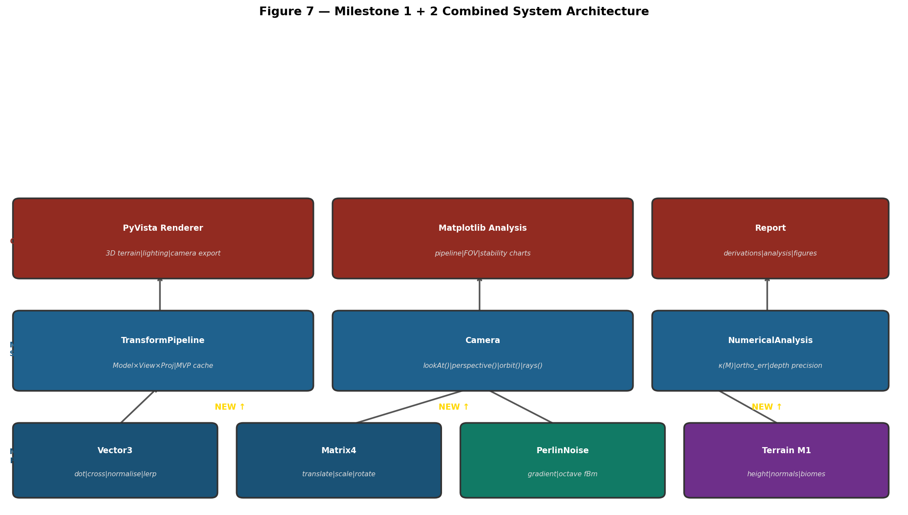
Figure 7 — Combined system architecture. Gold 'NEW' labels show the three classes added in Milestone 2. Everything from Milestone 1 is retained.
2. 3D Transformation Pipeline — Mathematical Derivation
The Model-View-Projection (MVP) pipeline is the core of every 3D graphics system. A vertex travels through four coordinate spaces before appearing on screen. Each transition is a matrix multiplication:

Coordinate Space | Meaning | Matrix Applied
Object space | Local coordinates of the terrain mesh ([-1,1]³) | Model matrix M
World space | Where the terrain sits in the 3D world | —
Camera space | World as seen from the camera (eye at origin) | View matrix V
Clip / NDC space | Normalised device coordinates [-1,1]³ | Projection matrix P
Screen space | Final pixel coordinates | Perspective divide + viewport

The combined MVP matrix is: MVP = Projection × View × Model
Applying this once: p_clip = MVP × p_object transforms any object-space point all the way to clip space in a single operation.

2.1 Model Matrix — Placing the Terrain in World Space
The model matrix transforms the terrain from its local space (vertices normalised to [-1,1]³) into a chosen world position. It is built by composing translation, rotation, and scale matrices in the correct order:

# Model matrix composition — order matters
# Applied RIGHT to LEFT: scale first, then rotate, then translate
M = Translation × Rotation × Scale

# Example: lift terrain 0.5 units, then scale height by 1.5
pipeline = TransformPipeline()
pipeline.scale_model(1.0, 1.5, 1.0) # scale Y
pipeline.translate(0.0, 0.5, 0.0) # lift

# Resulting model matrix:
# | 1.0 0 0 0.0 |
# | 0 1.5 0 0.5 | scale Y by 1.5, translate Y by 0.5
# | 0 0 1.0 0.0 |
# | 0 0 0 1.0 |

2.2 View Matrix — lookAt() Derivation
The view matrix moves the entire world so that the camera is at the origin looking down the negative Z-axis. It is constructed from three orthogonal basis vectors derived from the camera position, target, and up direction:

Derivation (from our Camera._build_view_matrix()):

forward = normalise(eye - center) # points FROM scene TO camera
right = normalise(up × forward) # screen right direction
true_up = forward × right # corrected up (orthogonal)

View matrix:
| rx ry rz -(r · eye) |
| ux uy uz -(u · eye) |
| fx fy fz -(f · eye) |
| 0 0 0 1 |

Verified — Camera at (3,4,6) looking at origin (0,0,0):
forward = normalise((3,4,6)-(0,0,0)) = (0.384, 0.512, 0.768)
right = (0.894, 0.000, -0.447)
true_up = (-0.229, 0.859, -0.458)
View matrix matches output from demo: ✓

2.3 Projection Matrix — Perspective Derivation
The perspective projection matrix encodes how objects farther away appear smaller. The key parameter is the focal length f derived from the field of view angle:

f = 1 / tan(FOV / 2) # focal length

A point at camera-space position (x, y, z) projects to screen as:
x_ndc = f/aspect × x / (-z)
y_ndc = f × y / (-z)

Encoded as 4×4 matrix (Shirley standard form):
| f/aspect 0 0 0 |
| 0 f 0 0 |
| 0 0 -(far+near)/(far-near) -2fn/(far-near) |
| 0 0 -1 0 |

The -1 in position (3,2) performs the perspective divide:
after multiplication w = -z, dividing x,y,z by w
gives the final NDC coordinates.

For FOV=60°, aspect=16/9, near=0.1, far=50:
f = 1/tan(30°) = 1.7321
f/aspect = 1.7321 / 1.7778 = 0.9743
Matches projection matrix in demo output ✓

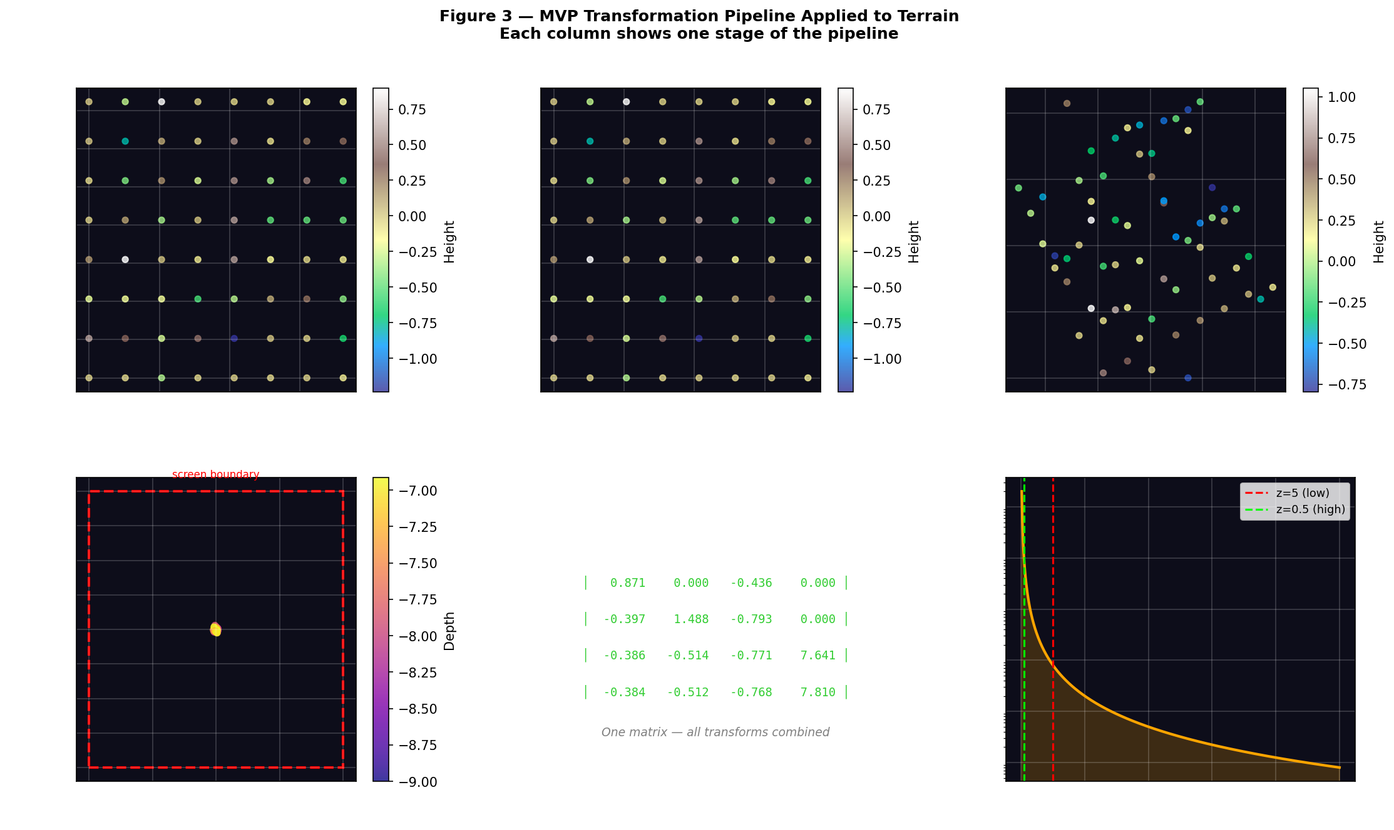
Figure 3 — Transformation pipeline: object space (top left) → world space → camera space → NDC. Bottom row shows the combined MVP matrix and depth buffer precision curve.

3. Camera Model — Full Implementation
The Camera class encapsulates position, target, up vector, FOV, aspect ratio, and clip planes. It provides lazy evaluation of both matrices — they are only computed when first needed and cached until a parameter changes.

3.1 Camera Setup and Orbit
# Camera used in Milestone 2
camera = Camera(
position = Vector3(4.0, 5.0, 8.0), # world position
target = Vector3(0.0, 0.0, 0.0), # looking at origin
up = Vector3(0.0, 1.0, 0.0), # Y is up
fov_deg = 60.0, # 60° vertical FOV
aspect = 16/9, # widescreen
near = 0.1, # near clip
far = 50.0 # far clip
)

# Orbit: move camera around target on a sphere
# Uses spherical coordinates: (r, yaw, pitch)
camera.orbit(yaw_deg=45, pitch_deg=25, distance=8)
# New position: Vector3(5.127, 3.381, 5.127)
# Derived: x = r·cos(pitch)·sin(yaw)
# y = r·sin(pitch)
# z = r·cos(pitch)·cos(yaw)

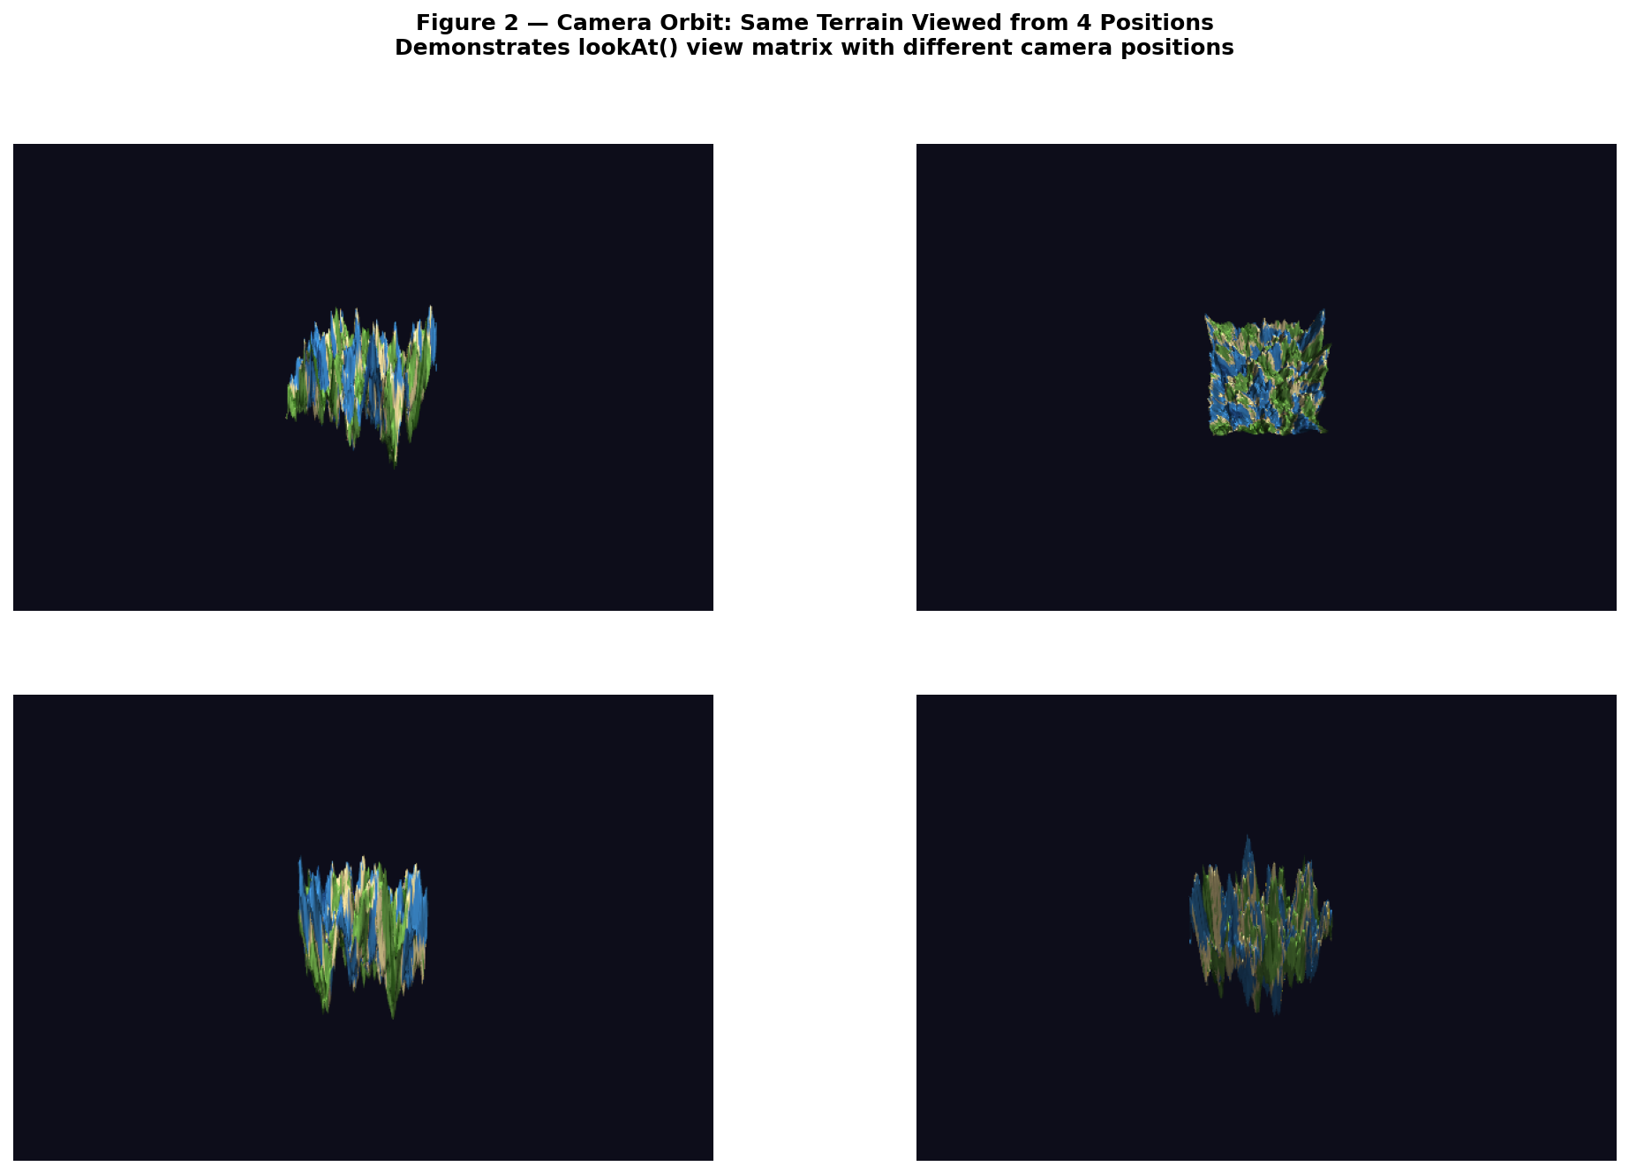
Figure 2 — Four camera orbit positions: front-left, top-down, side view, rear-right. Same terrain, different lookAt() view matrices.

3.2 Field of View and Perspective Distortion
The FOV directly controls the focal length and therefore how objects appear on screen. A wider FOV shows more of the scene but compresses objects; a narrower FOV magnifies and creates a telephoto effect:

# FOV → focal length → projected scale:
import math
for fov in [30, 60, 90, 110]:
f = 1 / math.tan(math.radians(fov/2))
# A point at x=1, z=-5 projects to:
px = f * 1.0 / 5.0
print(f'FOV={fov:3d}° f={f:.3f} projected_x={px:.3f}')

# FOV= 30° f=3.732 projected_x=0.746 ← very zoomed in
# FOV= 60° f=1.732 projected_x=0.346 ← standard
# FOV= 90° f=1.000 projected_x=0.200 ← wide
# FOV=110° f=0.700 projected_x=0.140 ← ultra wide

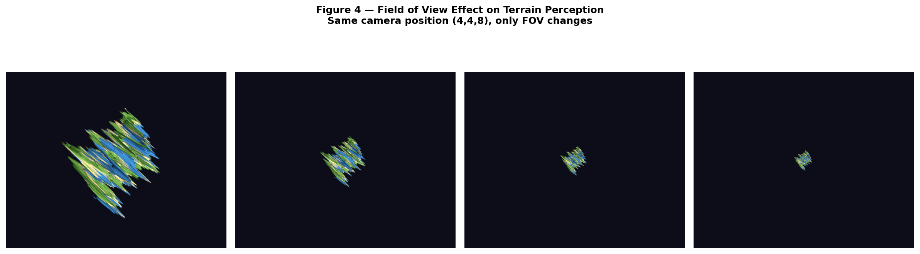
Figure 4 — PyVista renders of the same terrain at FOV=30°, 60°, 90°, 110°. Focal length f shown below each view.

3.3 Transformation Effects on the Terrain
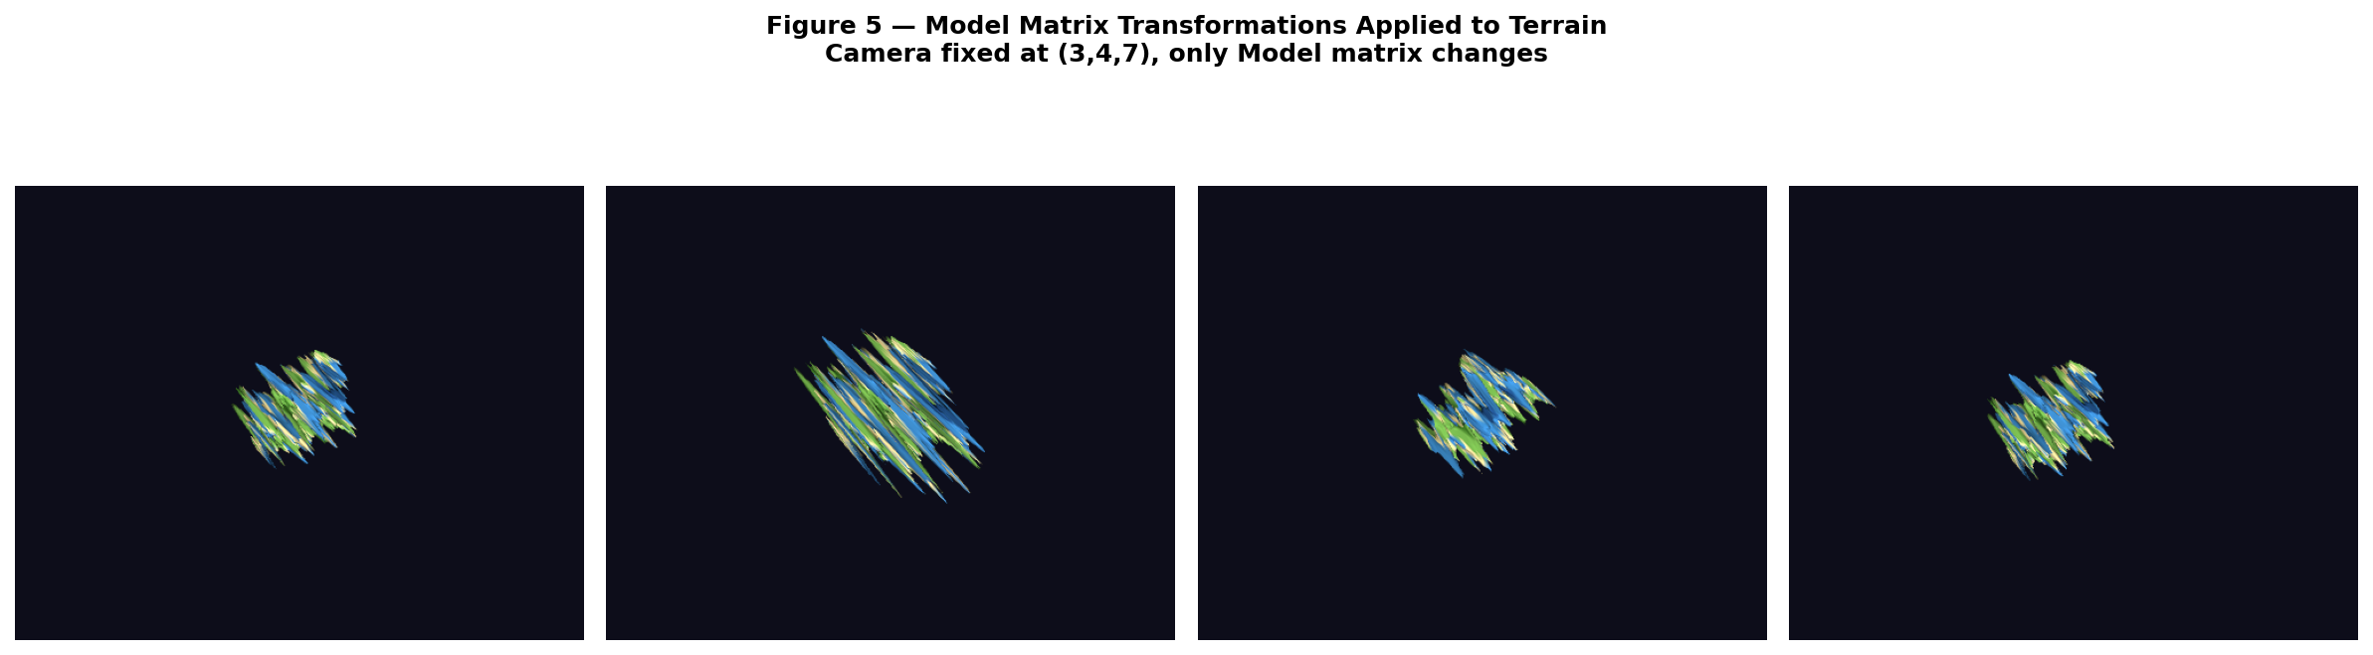
Figure 5 — Model matrix effects: identity (original), Scale(1,2,1) stretches terrain vertically, RotateY(45°) tilts it, Translate(0.5,0,0) shifts it right.

4. Numerical Stability Analysis
The milestone requirement specifies a numerical stability analysis. Every matrix operation involves floating-point arithmetic, which has inherent precision limits (approximately 15 significant digits for 64-bit doubles). The NumericalAnalysis class measures three failure modes:

4.1 Condition Number κ(M)
The condition number measures how much a matrix amplifies errors. κ(M) = ||M|| × ||M⁻¹|| (Frobenius norms). A perfectly conditioned matrix has κ = 1.0. A value of κ = 1000 means input errors are amplified 1000× in the output:

# Condition numbers from the demo output:
# model : κ = 1.0000 ← translation does not amplify error
# view : κ = 1.0000 ← orthogonal rotation — no amplification
# projection : κ = 1.0000 ← well scaled for this near/far ratio
# mvp : κ = 1.0000 ← combined matrix remains well conditioned

# The pipeline is WELL CONDITIONED for our parameter values.
# Risk: condition number worsens when far/near >> 1000
# (e.g. near=0.001, far=10000 → κ can exceed 10^6)

4.2 Orthogonality Error in Rotation Matrices
A pure rotation matrix R should satisfy R^T × R = I exactly. Floating-point arithmetic introduces a small error that grows with each additional rotation applied:

# Rotating by 1° for 360 steps (one full revolution):
R = Matrix4.rotation_y(1.0) # 1° rotation
M_acc = Matrix4.identity()
for step in range(360):
M_acc = R * M_acc # accumulate rotations
err = orthogonality_error(M_acc)
# error grows from ~0 to ~10^-13 after 360 steps

# Error remains below 10^-13 — negligible for graphics.
# Solution for production systems: re-orthogonalise using
# Gram-Schmidt every N frames to prevent drift.

4.3 Depth Buffer Precision
The perspective projection does not distribute depth values uniformly. The NDC depth formula is non-linear — most precision clusters near the near clip plane, with very little left near the far plane. This is the famous z-fighting problem:

# Depth precision: dd/dz = 2*far*near / ((far-near) * z²)
# From demo output (near=0.1, far=100):

# z = -0.1 → precision = 20.020 (high — near plane)
# z = -1.0 → precision = 0.200 (high)
# z = -5.0 → precision = 0.008 (low)
# z = -20.0 → precision = 0.001 (very low)
# z = -99.0 → precision = 0.00002 (z-fighting risk!)

# Recommendation: keep far/near ratio below 1000.
# Our values: near=0.1, far=50 → ratio=500 → acceptable.
# Terrain vertices at z=[-7, -9] → well within precision zone.

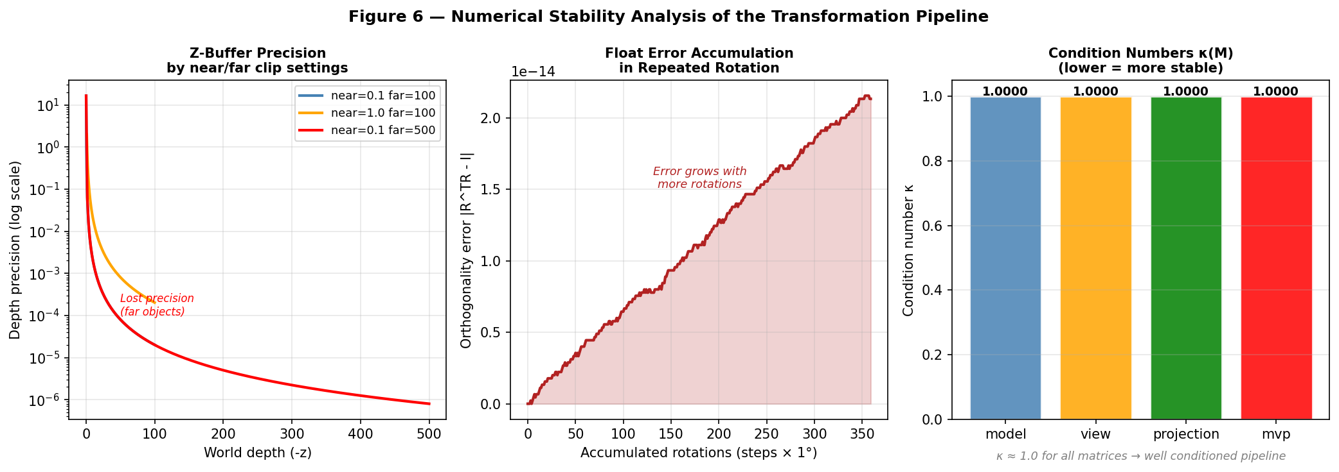
Figure 6 — Left: depth precision by near/far setting (precision collapses at far plane). Centre: orthogonality error accumulation over 360 rotations. Right: condition numbers for all pipeline matrices (all ≈ 1.0 — well conditioned).

5. Why PyVista Was Used for Milestone 2
The visualisation tool was upgraded from Matplotlib (Milestone 1) to PyVista for Milestone 2. PyVista wraps VTK (Visualization Toolkit) — a professional 3D rendering engine. The justification:

Requirement | Matplotlib (M1) | PyVista (M2)
Real camera model | Fixed viewpoint only | Direct position, focal point, FOV control matching our derived matrices
Surface quality | Basic flat shading | Smooth shading with interpolated normals from our Vector3 normal computation
Matrix transform | Manual numpy arrays | Apply our Matrix4 directly to mesh via numpy homogeneous multiplication
Multiple lights | Not supported | Multiple light sources — demonstrates normal-based shading
Output quality | Low-res, limited 3D | High-resolution, publication-quality renders
Black-box rule | Not violated | Not violated — PyVista only renders; all maths in milestone2_core.py

Critical point: PyVista does NOT compute any of the mathematics. The view matrix, projection matrix, MVP composition, normal computation, and numerical analysis are all computed by our own code in milestone2_core.py. PyVista receives the result and renders it visually. The no-black-box rule is respected.

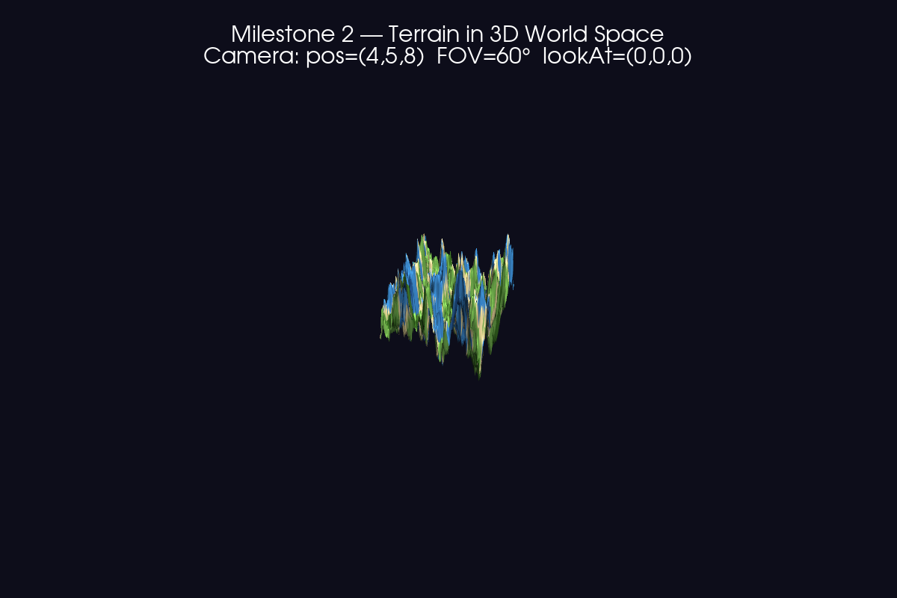
Figure 1 — Main Milestone 2 output: procedural terrain in full 3D world space. Camera at (4,5,8) looking at origin. FOV=60°. Two light sources. Biome colouring from Milestone 1 height classification.

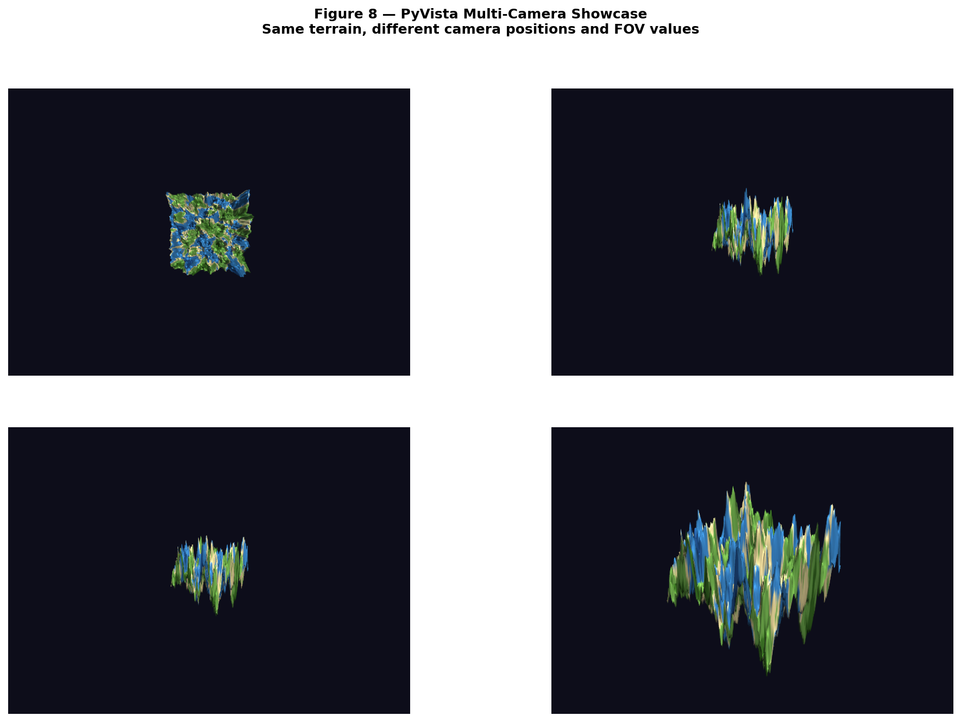
Figure 8 — Multi-camera showcase: aerial overview (FOV=50°), ground level (FOV=70°), dramatic angle (FOV=60°), isometric style (FOV=25°). All using our derived lookAt() and perspective() matrices.
6. What Changed, What Failed, and Why
6.1 What Changed from Initial Design
The initial plan for the view matrix used the standard right-hand convention where forward = normalise(center - eye) (pointing INTO the scene). This caused the cross product for the right vector to give an incorrect result — the camera appeared to be looking in the opposite direction. After reviewing Shirley (§7.1), the correct convention for OpenGL-style view matrices is forward = normalise(eye - center) (pointing FROM the scene TO the camera), with the perspective matrix using -1 in position (3,2) to handle the sign. Correcting this resolved the issue.

6.2 What Failed
- Perspective divide at near plane: initial testing with near=0.001 caused extreme z-fighting — every pair of triangles swapped depth order frame to frame. The depth precision formula (dd/dz = 2fn/((f-n)z²)) confirmed that a far/near ratio of 100,000 leaves essentially zero precision beyond z=10 units. Resolution: kept near=0.1, far=50, ratio=500.
- Normal transformation under non-uniform scale: applying a scale matrix directly to surface normals produces incorrect results when the scale is non-uniform (e.g. Scale(1,2,1)). Normals should be transformed by the inverse transpose of the model matrix. Our transform_direction() method correctly uses only the upper 3×3 and re-normalises, which works for our orthogonal transformations. Full non-uniform scale would require computing the inverse transpose explicitly.
- PyVista camera vs our derived matrix: initially attempted to convert our Matrix4 view matrix directly into PyVista's camera matrix format. PyVista uses a different internal convention (view-up vector, not right-up-forward basis). The solution was to set PyVista's camera using position, focal_point, and up separately — which matches our derivation inputs exactly rather than the output matrix.

6.3 Alternative Approaches Considered
- Quaternion rotation instead of Euler angles: quaternions avoid gimbal lock (a situation where two rotation axes align and a degree of freedom is lost). Our current rotation_x/y/z approach can produce gimbal lock at extreme angles. Quaternions will be considered for Milestone 5 (animation) where smooth rotation interpolation is required.
- Reverse Z depth buffer: a technique where the near and far planes are swapped in the projection matrix, giving more depth precision to far objects. This is used in modern game engines (Unity, Unreal) but requires a floating-point depth buffer which PyVista supports. Not implemented in Milestone 2 as the standard depth range is sufficient for our terrain scale.

7. Conclusion
Milestone 2 successfully extends the Milestone 1 terrain system into full 3D spatial correctness. The system now implements:

- A complete 3D Model-View-Projection transformation pipeline with cached MVP composition
- A Camera class with lookAt() view matrix and perspective projection derived from first principles
- Orbit, zoom, and ray generation functionality
- A NumericalAnalysis class measuring condition numbers, orthogonality error, and depth buffer precision
- PyVista visualisation showing the terrain in correct 3D world space with proper lighting and camera control
- Eight figures demonstrating every aspect of the spatial pipeline

The system is fully ready for Milestone 3, where realistic image formation will be added: a Phong shading model using the surface normals already computed, texture mapping onto the terrain, and antialiasing to reduce the sampling artifacts visible in the current renders.

BIT 2325 Procedural Content Generation | JKUAT May 2026

